|  |  |  |
| --- | --- | --- |
| **Academic Year:** 2024-25 | **Year:** Third Year | **Semester:** II |
| **PRN No.: 1012412079** | **Name: Ratnajeet Patil** | |
| **Subject:** Database Management System | | |
| **Assignment No.**: 7 |  | |
| **Date:** |  | |

**Lab Assignment: 07**

**Title: Stored Procedure and Functions**

**Write and Execute Stored Procedures to perform following kind of operations:**

**Theory:**

What is Stored Procedure?

A **Stored Procedure** is a set of SQL statements that are stored in the database and can be executed repeatedly. It is a **routine** that can accept parameters, execute SQL queries, and perform tasks like inserting, updating, or deleting data. Stored procedures are mainly used to **encapsulate complex logic** and to **improve performance** by minimizing the number of calls made between the application and the database.

What is Function?

A **Function** is a stored routine that performs a specific task and **returns a value**. Functions are similar to stored procedures, but they are designed to **return a single value** (usually a scalar value or a table) and are usually used in SELECT queries or expressions.

Compare Stored Procedure with Function

|  |  |  |
| --- | --- | --- |
| **Feature** | **Stored Procedure** | **Function** |
| **Return Type** | Can return multiple result sets or output parameters (no return value by default) | Always returns a single value or a table |
| **Can Modify Database** | Yes, can perform actions like INSERT, UPDATE, DELETE | No, cannot modify the database (unless specifically allowed) |
| **Usage in Queries** | Cannot be used directly in a SELECT statement | Can be used in SELECT, WHERE, JOIN, or any SQL expression |
| **Calling Method** | Invoked explicitly using CALL or similar command | Invoked in SQL expressions or queries (e.g., SELECT function_name() ) |
| **Side Effects** | Can have side effects (e.g., modifying tables or changing the state of the database) | Should not have side effects, should only calculate and return a value |
| **Return Value** | No direct return value, but can return output parameters | Always returns a value (or set of values) |
| **Transaction Control** | Can control transactions (begin, commit, rollback) | Cannot control transactions |

**Execution:**

**1. Retrieve Records with Condition (Stored Procedure)**

Question:  
Create a stored procedure get_employees_by_dept that retrieves all employee records from the employees table where the department_id matches the input parameter.

**2. Input and Output Parameters (Stored Procedure)**

Question:  
Write a stored procedure get_salary_by_id that takes an emp_id as an input parameter and returns the corresponding employee’s name and salary as output parameters from the employees table.

**3. Insert a New Record (Stored Procedure)**

Question:  
Design a stored procedure add_new_product to insert a new product into the products table. The procedure should accept parameters for product name, category, price, and quantity, and insert them into the table.

**4. Conditional Logic with IF/CASE (Stored Procedure)**

Question:  
Create a stored procedure check_order_status that accepts an order_id and checks its status from the orders table.

* If the status is ‘Pending’, return a message 'Order is yet to be processed'.
* If the status is ‘Shipped’, return 'Order has been shipped'.
* If status is anything else, return 'Unknown status'.

Use IF or CASE statements for branching logic.

**5. Calculation Using Function**

Question:  
Write a stored function calculate_bonus that accepts an employee’s salary and bonus percentage as parameters, calculates the bonus amount, and returns the result.

**6. String Manipulation (Function)**

Question:  
Design a stored function format_full_name that accepts first name and last name as input and returns a formatted full name in the format: LASTNAME, Firstname (all uppercase for last name).

**7. Data Validation Before Insert (Stored Procedure)**

Question:  
Develop a stored procedure register_user that accepts user details (username, email, age).  
Before inserting into the users table:

* Validate that age is at least 18.
* Check that the username does not already exist.  
  If validations pass, insert the record; otherwise, return an error message.

**8. Error Handling in Stored Procedure**

* **Question:**  
  Write a stored procedure update_product_price that updates the price of a product in the products table.  
  Include error handling mechanism to display appropriate error messages.

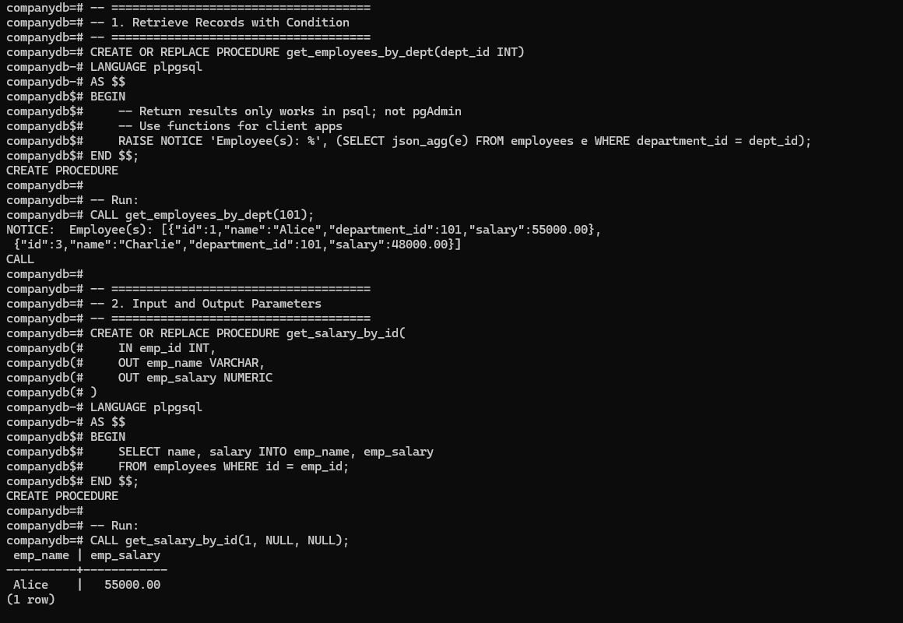

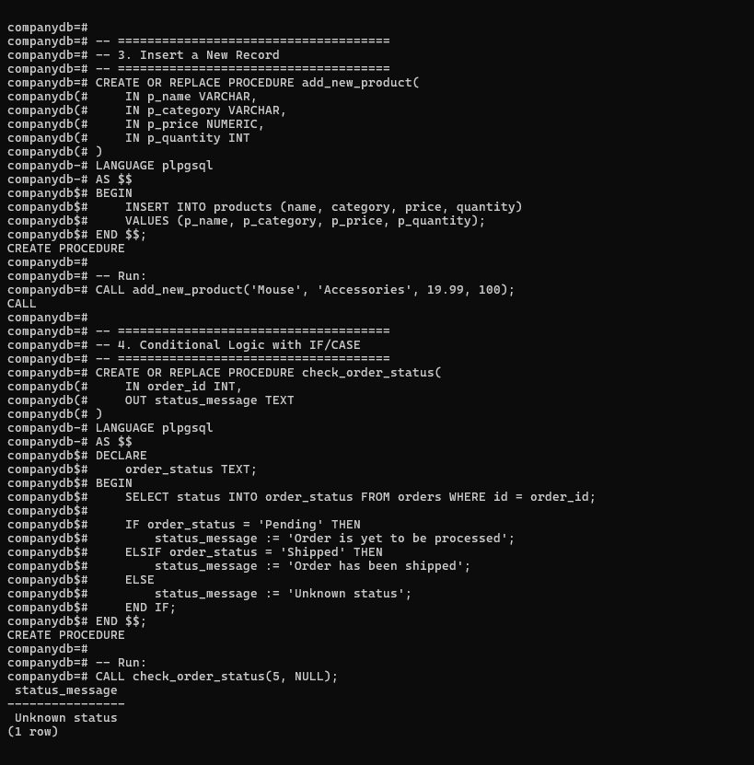

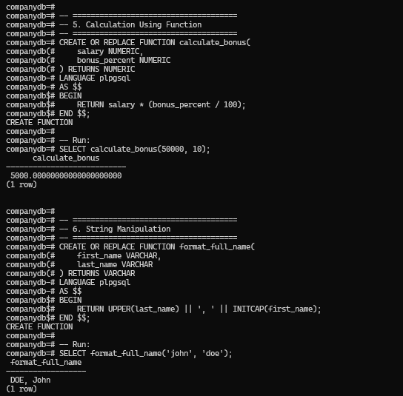

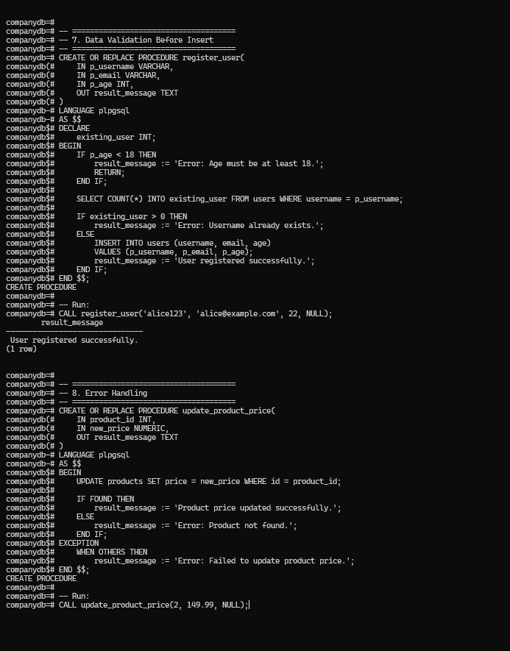

**Conclusion:**

**FAQs:**

1. What is PL/SQL?

**PL/SQL (Procedural Language/SQL)** is Oracle's procedural extension to SQL. It combines the power of SQL with the procedural features of programming languages, such as variables, control structures (loops, conditionals), error handling, and more. PL/SQL allows users to write complex SQL operations within procedures, functions, and triggers.

1. What are different types of Parameters used in stored procedure?

There are three main types of parameters used in stored procedures:

* **IN Parameters**:
  + These are **input parameters**.
  + They provide data to the procedure when it is called.
  + They are **read-only** during the procedure execution.
  + Example: IN dept_id INT
* **OUT Parameters**:
  + These are **output parameters**.
  + They are used to **return values** from the procedure back to the caller.
  + They are **initialized inside the procedure**.
  + Example: OUT result_message TEXT
* **INOUT Parameters**:
  + These parameters act as both **input and output**.
  + They are used to **pass a value to the procedure** and also **receive a modified value** after the procedure execution.
  + Example: INOUT balance NUMERIC

1. Compare SQL and PL/SQL.

|  |  |  |
| --- | --- | --- |
| **Feature** | **SQL** | **PL/SQL** |
| **Purpose** | A **query language** used to manage and manipulate relational databases. | A **procedural language** used to write logic for executing SQL operations with control structures, error handling, etc. |
| **Usage** | Used for writing **queries** and **DML operations** (INSERT, UPDATE, DELETE). | Used to create **procedures**, **functions**, **triggers**, and control the flow of execution of SQL queries. |
| **Execution Model** | Executes one SQL statement at a time. | Executes a block of SQL statements as a program with **variables**, **loops**, and **conditionals**. |
| **Control Structures** | Does not support procedural constructs like loops or conditionals (except in queries like CASE). | Supports loops, conditionals, exception handling, and other procedural constructs. |
| **Error Handling** | Error handling is done using **SQLSTATE** codes or **exception clauses** (though limited). | Error handling is more robust with **exception blocks** that allow managing errors explicitly. |
| **Performance** | Executes individual SQL queries that can be optimized by the database. | **Performance** is enhanced by minimizing the number of calls to the database through batch operations. |
| **Variables** | Does not support the use of variables. | Supports variables, constants, and cursors. |
| **Modifying Data** | Can modify data through SQL commands like INSERT, UPDATE, and DELETE. | Can execute SQL commands and can also modify data, but more suited for complex logic. |

1. How error handling works in stored procedure?

Error handling in stored procedures can be done using **Exception Handling** in PL/SQL. The key component for error handling is the **EXCEPTION** block, which allows you to handle errors gracefully and take appropriate actions when an error occurs during procedure execution.